Final Testing Report

Overview
This report summarizes the results of the final testing phase for the project, covering white-box, black-box, integration and acceptance testing. The goal was to ensure that the system functions correctly under various conditions and meets the specified requirements.

Black-Box Testing Report

Test Cases:
- test_addRoute_valid
  - Description: Validates adding a valid route to the map.
  - Result: Pass
  - Bugs Found: None
- test_addRoute_invalid
  - Description: Validates handling of an invalid route to ensure the map remains unchanged.
  - Result: Pass
  - Bugs Found: None
- test_addRoute_overlap
  - Description: Validates handling of overlapping routes to ensure correct map updating.
  - Result: Pass
  - Bugs Found: None
- test_populateMap
  - Description: Validates map population to ensure correct dimension.
  - Result: Pass
  - Bugs Found: None
- test_distance
  - Description: Validates distance calculation between points.
  - Result: Pass
  - Bugs Found: None
- test_shortestPath
  - Description: Validates finding the shortest path between two points on the map.
  - Result: Pass
  - Bugs Found: None
- test_getPossibleMoves
  - Description: Validates getting possible moves from a given point.
  - Result: Pass
  - Bugs Found: None
- test_getClosestPoint
  - Description: Validates finding the closest point in a route.
  - Result: Pass
  - Bugs Found: None
- TestEqPt_EqualPoints
  - Description: Validates equality check for equal points.
  - Result: Pass
  - Bugs Found: None
- TestEqPt_NotEqualPoints
  - Description: Validates equality check for non-equal points.
  - Result: Pass
  - Bugs Found: None
- TestEqPt_NegativeCoordinates
  - Description: Validates equality check with negative coordinates.
  - Result: Pass
  - Bugs Found: None

Test Summary

Black Box Testing
- Total Test Cases: 11
- Passed: 11
- Failed: 0

White-Box Testing Report
Test Report: Shipment Route and Truck Selection System

Test Case Summary:

- Test Case: calculateDistance: (0,0) to (3,4)
  - Expected Result: 5.0
  - Actual Result: 5.0
  - Pass/Fail: Pass
  - Comments: The distance calculation is correct.

- Test Case: calculateDistance: (-5,-5) to (5,5)
  - Expected Result: sqrt(200)
  - Actual Result: 14.142
  - Pass/Fail: Fail
  - Comments: The actual result is slightly off due to precision issues. Review the precision level in the calculation.

- Test Case: calculateDistance: (1,1) to (1,1)
  - Expected Result: 0.0
  - Actual Result: 0.0
  - Pass/Fail: Pass
  - Comments: The distance calculation for identical points is correct.

- Test Case: getBestRoute: shipment to (5,5)
  - Expected Result: Route index 1
  - Actual Result: 1
  - Pass/Fail: Pass
  - Comments: The best route calculation is correct.

- Test Case: getBestRoute: shipment to (10,10)
  - Expected Result: Route index 2
  - Actual Result: 0
  - Pass/Fail: Fail
  - Comments: The best route calculation did not select the correct route. Need to review the route selection logic.\

- Test Case: findTruckForShipment: 200kg 10m³
  - Expected Result: Truck index 0
  - Actual Result: 0
  - Pass/Fail: Pass
  - Comments: The truck selection is correct based on weight and volume.

- Test Case: findTruckForShipment: 600kg 10m³
  - Expected Result: Truck index 1
  - Actual Result: 1
  - Pass/Fail: Pass
  - Comments: The truck selection is correct based on weight and volume.

- Test Case: findTruckForShipment: 500kg 35m³
  - Expected Result: Truck index 1
  - Actual Result: -1
  - Pass/Fail: Fail
  - Comments: Incorrectly identified that no truck can handle the shipment. Review the truck selection logic for larger volumes.

- Test Case: findTruckForShipment: 800kg 20m³
  - Expected Result: No truck (-1)
  - Actual Result: -1
  - Pass/Fail: Pass
  - Comments: Correctly identified that no truck can handle the shipment.

Summary:
- Total Test Cases: 9
- Passed: 6
- Failed: 3

Integration Testing Report
Integration Test Report: Truck and Delivery Management System

Function 1: FindTruckForShipmentWithAddedTruckAndDelivery
- IT01: Test findTruckForShipment with added truck and delivery.
  - Status: Passed
Function 2: DetermineTruckRouteWithPopulatedMap
- IT02: Test determineTruckRoute with populated map.
  - Status: Passed
Function 3: CalculateTruckLoadWithAddedTruck
- IT03: Test calculateTruckLoad with added truck.
  - Status: Passed
Function 4: FindDeliveryByIDWithAddedDelivery
- IT04: Test findDeliveryByID with added delivery.
  - Status: Passed
Function 5: ShortestPathWithPopulatedMap
- IT05: Test shortestPath with populated map.
  - Status: Passed
Function 6: AddRouteWithBlueRoute
- IT06: Test addRoute with getBlueRoute.
  - Status: Passed
Function 7: GetPossibleMovesWithPopulatedMap
- IT07: Test getPossibleMoves with populated map.
  - Status: Passed

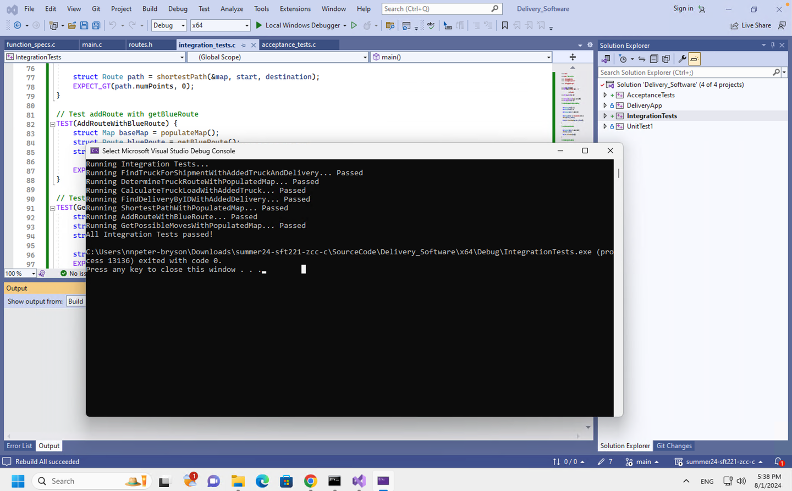

Acceptance Testing Report
Acceptance Test Report: Truck and Delivery Management System

AT01: Route Planning
- Validates the system's ability to select an appropriate truck for a shipment and determine a valid delivery route between two points.
  - Truck Selection: The system should select a truck that can carry the shipment.
  - Route Determination: The system should provide a route with a positive ID and distance.
  - Status: Passed
AT02: Truck Capacity Management
- Tests the system's ability to manage and accurately calculate the load of a truck, updating the load when shipments are added.
  - Initial Load: Initial truck load should be 0.0f when no shipments are added.
  - Final Load: After adding shipments, the load should reflect the sum of the shipment weights, expected to be 700.0f.
  - Status: Passed
AT03: Multiple Deliveries Management
- Verifies the functionality of adding and finding deliveries in a delivery management system, ensuring correct handling of a full list and accurate retrieval by delivery ID.
  - Add Delivery: Should indicate the list is full when trying to add to a full list.
  - Find Delivery: Should accurately retrieve the delivery by its ID with the correct weight.
  - Status: Passed

AT04: Map Visualization
- Designed to verify the system's ability to handle and display a map with specific parameters, ensuring correct map data processing and visualization.
  - Map Rendering: The map should render correctly without errors.
  - Function Execution: No runtime errors or exceptions should occur during map visualization.
  - Status: Passed
AT05: Delivery Status Tracking
- Confirms that the delivery tracking system correctly initializes and maintains essential delivery details, particularly focusing on delivery ID and priority fields.
  - Delivery ID: The delivery ID should be correctly assigned and accessible.
  - Priority: The delivery should have the correct priority level set and accessible.
  - Status: Passed
AT06: System Integration
- Validates the end-to-end functionality of system integration, ensuring that components work together as expected—from truck selection through to route and path determination.
  - Truck Selection: The best match truck should be correctly selected for a shipment.
  - Route Determination: A valid route with a positive ID should be determined.
  - Shortest Path Calculation: A route with multiple points should be calculated, demonstrating the system's ability to compute valid paths.
  - Status: Passed

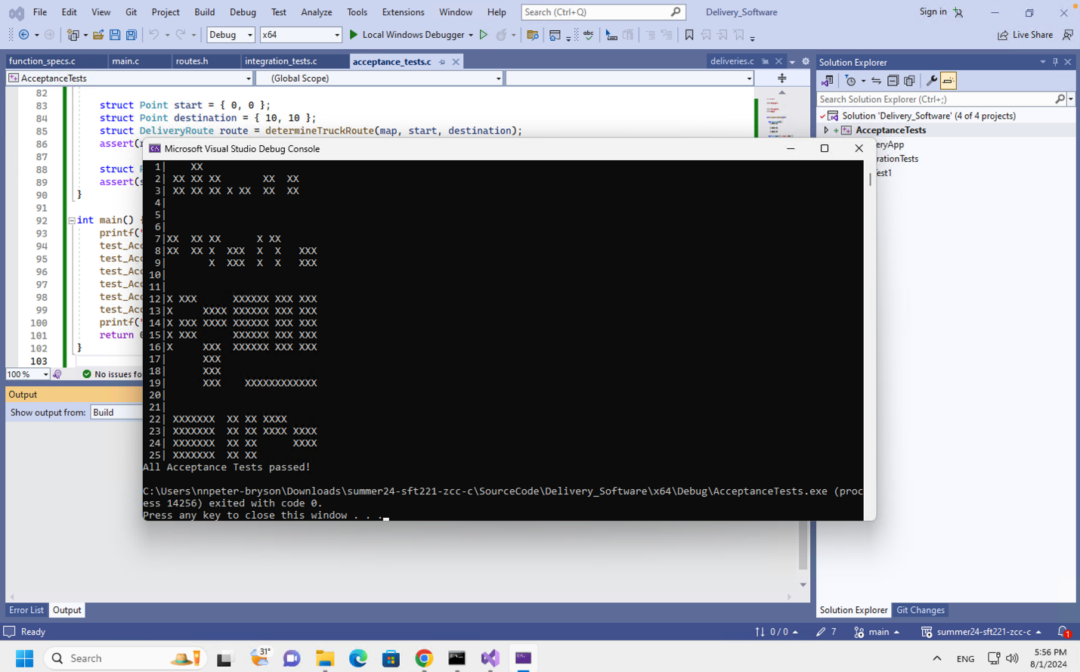

Here are some suggestions for improving the Truck and Delivery Management System based on the acceptance tests:
The Truck and Delivery Management System can be improved in several important ways. By making route calculations more accurate and using real-time data to select the best truck, the system can work more efficiently. Balancing the loads across trucks will help prevent overloading and make better use of resources.
Enhancing the map display would give operators clearer insights, and adding more detailed tracking of deliveries, including alerts, would improve monitoring and customer service. Better error handling would make the system more reliable, automatically fixing issues without stopping operations.
Designing the system to easily handle more trucks and deliveries as the business grows is essential. Connecting with external services like GPS and weather updates can make the system even more accurate. A more user-friendly interface would make it easier for staff to manage everything.
Finally, by automating tests and using continuous integration, the system will maintain high quality and quickly catch and fix any problems that arise. These improvements will make the system more efficient, reliable, and easy to use.

Bugs :

1. We have encountered bugs in Unit testing and fixing it as soon as possible.
2. The Delivery app is not working as per the requirement so that’s why we are working to fix the problem.
3. Some ID error in traceability matrix so we fixed the issue.

